The Joy Luck Club Summer Work
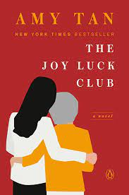
Directions: Please answer the questions in at least a paragraph. Please type your answers. Be sure to explain how your evidence proves your claim.

- Choose a character and answer the following questions: How did the author develop (beginning, middle, end) the character? Explain using specific examples from the text. Be sure not to just retell the plot.
- Choose a different character and answer the following question: How does the time AND place affect the actions of this character. Explain using examples from the text.
- How does the author’s use of point of view affect the story? Explain using specific examples from the text.
- What is a major conflict of the novel? (Choose a conflict that hasn’t been already addressed in the earlier questions.) Explain using details from the text.
- How does your novel challenge or reinforce social norms? (Think gender roles, generational difference, culture, language, etc.) Explain using details from the text.

